HANDY REFERENCE SHEET – HRP/STATS 261, Discrete Data
Binary predictor
Binary outcome

2x2 Contingency Tables

 | Disease (D) | No Disease (~D)
Exposed (E) | a | b
Unexposed (~E) | c | d

Measures of Association
Risk Ratio = 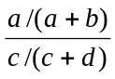

95% CI: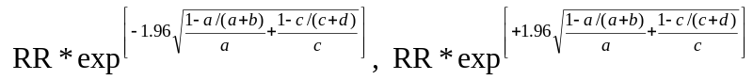

Odds Ratio = 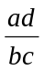

95% CI: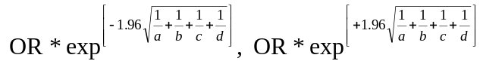

Difference in Proportions:
H₀: 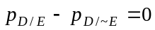 [for case-control study: 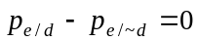]
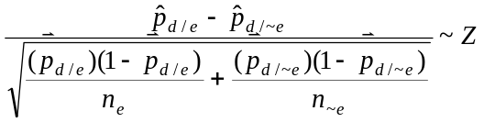Test Statistic:

95% CI: 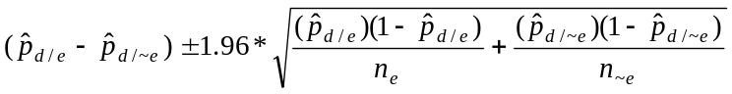

SAS CODE:
proc freq data=yourdata;
tables yourExposure*yourOutcome /measures cl;
weight counts; *if you have grouped data;
run;
2x2xK Contingency Tables
Notation: outcome=d; predictor=e; categorical covariate=k
Binary predictor
Binary outcome
Categorical covariate

Steps
- Calculate crude OR_{d-e} (or RR_{d-e})
- Calculate stratum-specific OR’s: OR_{d-e/k=K}
- If crude OR and stratum-specific OR’s are all similar → STOP. k is unlikely to be a confounder or an effect modifier, and you may use usual methods for 2x2 table (see page i), ignoring k.
- If crude OR and stratum-specific OR’s differ→proceed to (a) or (b) below:
  - If stratum-specific OR’s are similar to each other → suspect confounding
(i) Apply Cochran-Mantel-Haenszel test of conditional independence:
    - H₀: e and d are conditionally independent.
    - 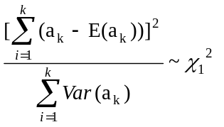Test Statistic:
 | Disease | No Disease
Exposed | a | b
Unexposed | c | d

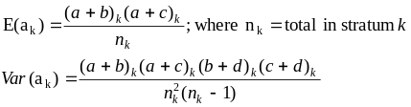
(ii) Calculate Mantel-Haenszel (MH) summary OR (adjusted for
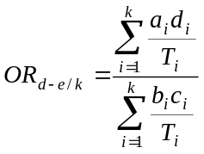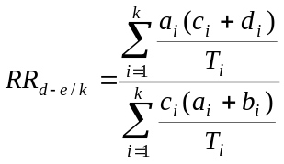confounding by k). If you rejected the null in (i), then MH OR should be ≠ 1.0. If you did not reject null in (i), then MH OR should be ≅1.0.
For RR:

  - If stratum-specific OR’s differ from each other→ suspect interaction (effect modification)
(i) Apply Breslow-Day test of homogeneity of the OR’s:
    - H₀: stratum-specific OR’s are equal (homogenous)
    - Test Statistic: complex→ use computer software
- If you reject null→ effect modification is present. Report stratum-specific OR’s
- If you fail to reject null→ insufficient evidence of effect modification; calculate Mantel-Haenszel summary OR, as above.

SAS CODE:
proc freq data=yourdata;
tables yourCovariate*yourExposure*yourOutcome /cmh;
weight counts; *if you have grouped data;
run;
Multi-way Contingency Tables:
Notation: x, y, and z are categorical variables
Categorical Variables that lack clear predictor/outcome distinction

Chi-square test of independence (RxC table):
H₀: x, y, and z are independent
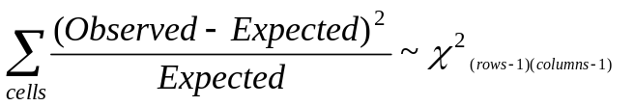Test Statistic:

Log-Linear Model

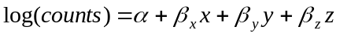+ interactions if appropriate

Odds ratio interpretation (if 2x2 table):
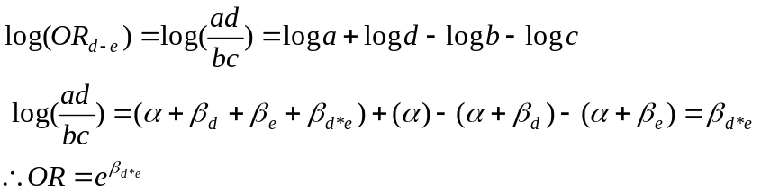

SAS CODE:
Chi-square test
proc freq data=yourdata;
tables yourX*yourY*yourK / chisq;
weight counts; *if you have grouped data;
run;

Log-linear models
proc genmod data=yourdata;
model total = yourX yourY yourK YourInteractions /
dist=poisson link=log pred;
run;

Logistic Regression
Unrestricted predictors and covariates
Binary outcome
Model:
Simplest form of the logistic likelihood (from 2x2):
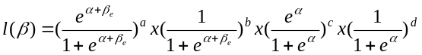
 | Disease | No Disease
Exposed | a | b
Unexposed | c | d

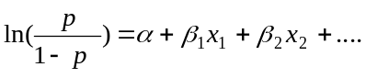

Tests of Model Fit:

Wald Test
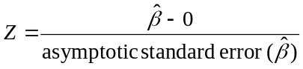

- 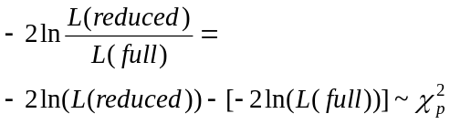Likelihood Ratio Test: where full model has n parameters and reduced model has n-p

Interpretation of Estimated Coefficients in Odds and Probabilities:
OR interpretation: OR_{exposure}=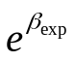

OR interpretation in the presence of interaction (two binary predictors):
ORexposure/interacting factor present =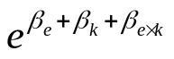
ORexposure/interacting factor absent =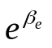

Probability interpretation: P(D/E) = 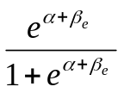

SAS CODE:
proc logistic data = analysis;
class YourPredictor_c (ref= "YourBaseline");
* automatic dummy coding to get >1 OR against the reference group;
model YourOutcome_c (event = "Yes") = YourPredictor / lackfit;
*lackfit gives Hosmer and Lemeshow goodness of fit chi-square test;
output out = OutDataSet p = Predicted;
*outputs predicted probabilities to new dataset;
run;
Pair-Matched Data

Pair-Matched Data
Binary Predictor
Binary Outcome

Case | Matched-control
 | Exposed | Unexposed
Exposed | a | b
Unexposed | c | d

Odds Ratio
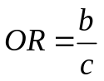

McNemar’s Test
    - H₀: exposure and disease are independent
    - Test Statistic:
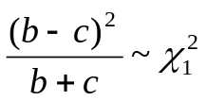

Matched Data
Unrestricted Predictors and Covariates
Binary Outcome

1:M Matched Data

Conditional Logistic Regression:
The simplest likelihood (from 2x2):
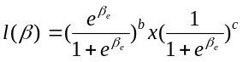

OR interpretation: OR_{exposure}=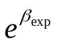

SAS CODE:** SAS V9 ONLY
proc logistic data = yourData ;
model YourOutcpme_c (event= "Yes") = YourPredictor1
YourPredictor2 YourPredictor3...;
strata MatchingVariable1 MatchingVariable2 / info;
output out = OutDataset p = Predicted;
run;

